USERTEST- Pamela K

Wild Camping - Bug report

Table of contents

Login for unregistered user

Image overlap on Home > View More

Alignment of search icon

User able to register email address as Username - potential GDPR breach

Profile Photo upload not completing

Add location - uploading image completing

### 

### 

### 

### 

### Login for unregistered user

**Env:** XX  
B**ranch:** XXX  
**Device**: Android 11 (Pixel 3)

**Pre requisites**

* User does not have a registered account

**Steps to reproduce:**

*NOTE: this is an intermittent issue and difficult to reproduce

* Navigate to Login screen
* Enter username and password
* When redirected back to login screen Enter the same username and password

**Expected result:**

* First attempt login: user is presented with an Error message ‘Username or password incorrect...’
* When the user tries to login the second time they are presented with the same error messaging around incorrect username and password

**Actual result:**

* First attempt login: user is presented with Error message ‘Username or password incorrect’
* When the user tries to login the second time with the same user details,they receive no Error message about incorrect Username and Password and instead are recognised as a registered user and being directed to brought to the User Profile screen

**Note from Developer:**

Unable to reproduce this bug right now. Further investigation required. If still unable to reproduce then may put in a speculative fix.   
Will advise QA or areas of the app that may be affected by code changes from speculate fix for a regression to be carried out on those areas.

### Image overlap on Home > View More

**Env:** XX  
B**ranch:** XXX  
**Device**: Android 11 (Pixel 3)

**Pre requisites**

* none

**Steps to reproduce:**

* From home screen, scroll to bottom of screen
* Select ‘view more’

**Expected result:**

* Image on location cards does not overlap onto heart icons

**Actual result:**

* Image on location cards is overlapping onto heart icons (see attached image)
* Issue is inconsistent

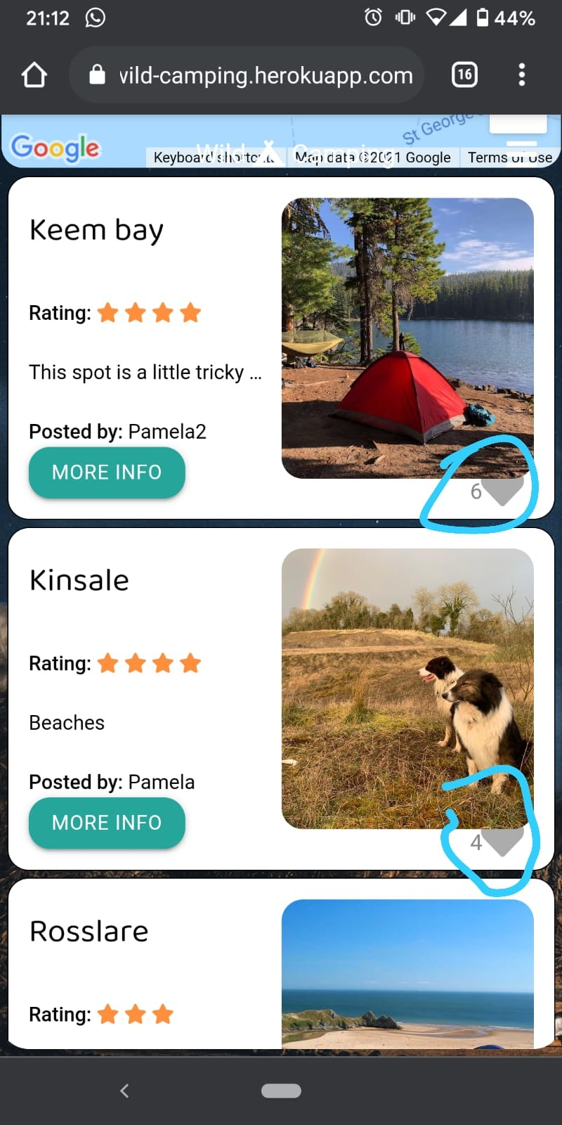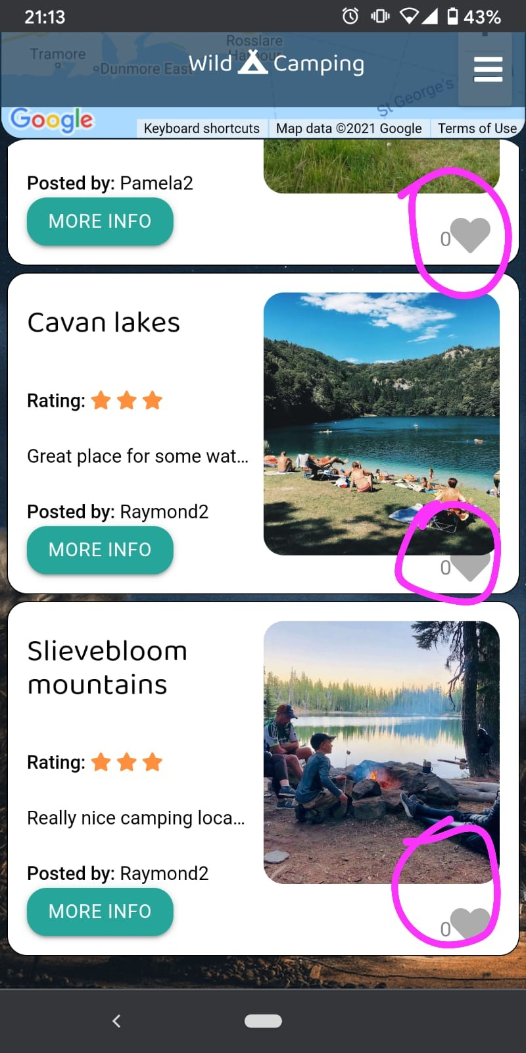

### Alignment of search icon

**Env:** XX  
B**ranch:** XXX  
**Device**: Android 11 (Pixel 3)

**Pre requisites**

* none

**Steps to reproduce:**

* From home screen, scroll to bottom of screen
* Select ‘view more’

**Expected result:**

* Search icon is aligned with Search bar

**Actual result:**

* Search icon is too high on the search bar (see screenshot below)

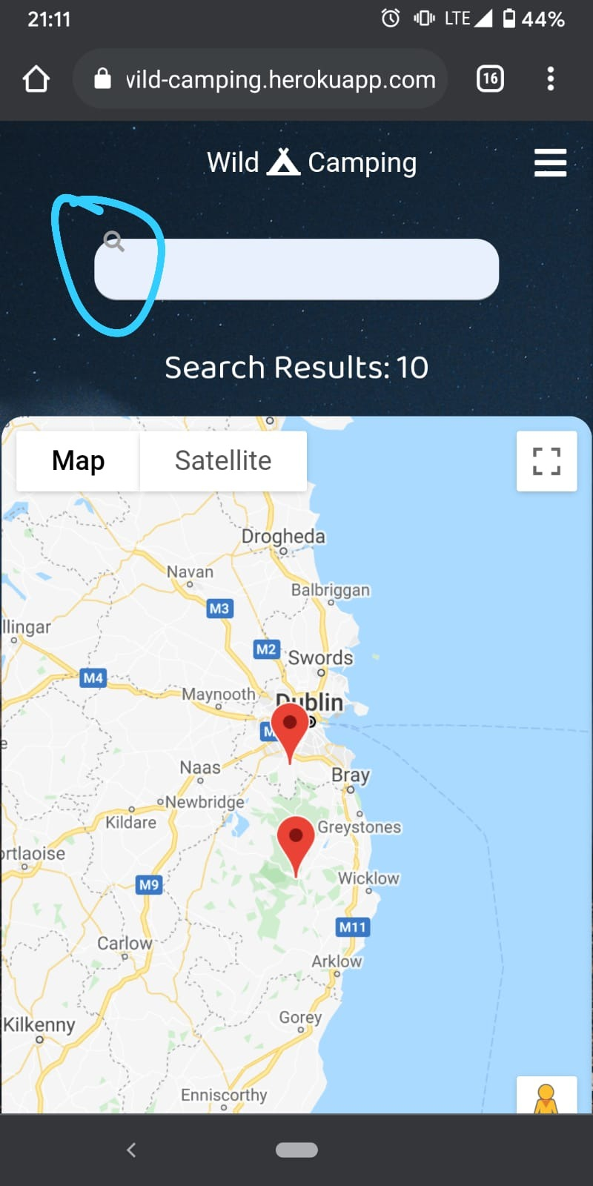

### User able to register email address as Username - potential GDPR breach

**Env:** XX  
B**ranch:** XXX

**Device**:   
Tested on below devices but issue is across all platforms

* Android 11 (Pixel 3)
* iOS 14.5.1 (iPhone Xr)

**Pre requisites**

* User has a registered an account and is logged in

**Steps to reproduce:**

* User logs in
* Navigates to the Profile screen

**Expected result:**

* Validation on the username text box which restricts users from entering special characters (i.e. @ / ! )

**Actual result:**

* User is able to enter their email address as their username. See attached screenshot

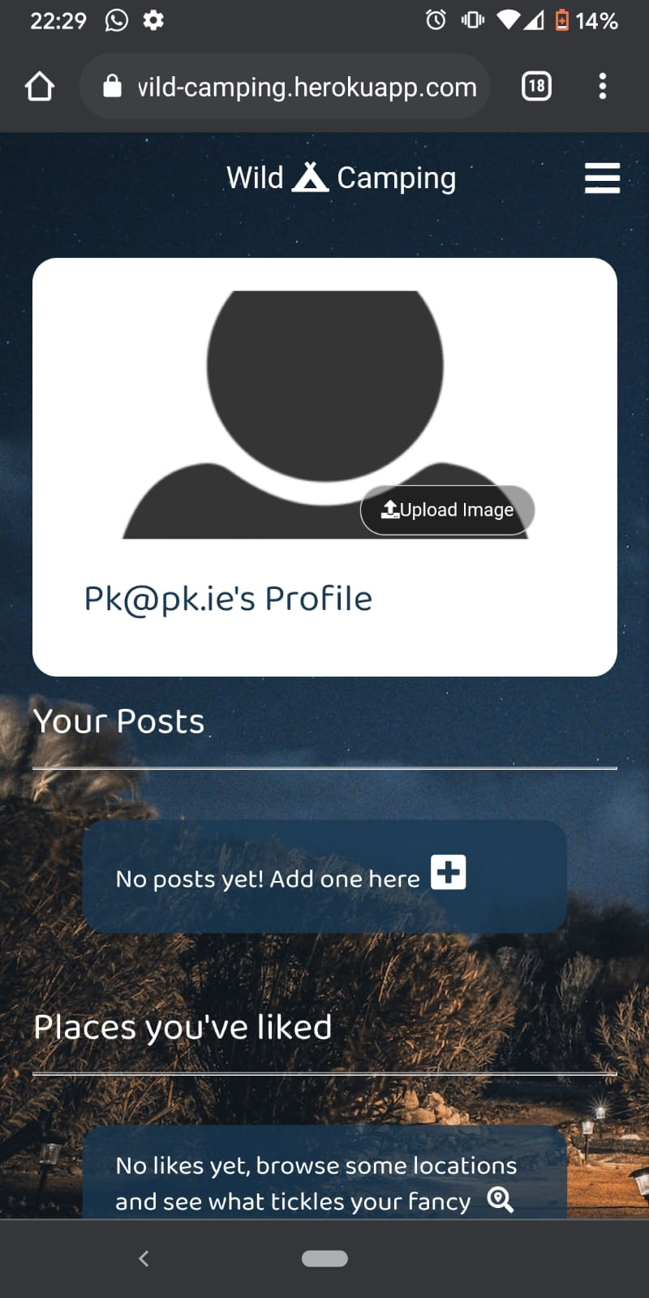

### Profile Photo upload not completing

**Env:** XX  
B**ranch:** XXX

**Device**:

* Android 11 (Pixel 3)
* iOS 14.5.1 (iPhone Xr)

**Pre requisites**

* User is registered and logged in

**Steps to reproduce:**

* Navigate to Profile screen
* Tap ‘upload image’
* Select image to upload from device

**Expected result:**

* User is prompted to confirm upload [TBC - not sure what expected result here should be. Should it be the OS that takes over or the app? Maybe OS permissions needs to happen here)
* Image is uploaded and stock image is replaced with new photo

**Actual result:**

* Users selects image from device
* Once the image is tapped the user is navigated back to the profile screen and no profile image has not been updated



### Add location - uploading image completing

**Env:** XX  
B**ranch:** XXX

**Device**:

* Android 11 (Pixel 3)

**Pre requisites**

* User is registered and logged in

**Steps to reproduce:**

* Navigate to ’Add location’
* Fill in form fields on page
* Select 'upload image’
* Select image to upload from device

**Expected result:**

* User is prompted to confirm upload [TBC - not sure what expected result here should be. Should it be the OS that takes over or the app? Maybe OS permissions needs to happen here)
* Image is uploaded and stock image is replaced with new photo

**Actual result:**

* Users selects image from device
* Once the image is tapped the user is navigated back to the profile screen and no profile image has not been updated

